**AddClient.java**

import java.rmi.*;

public class AddClient {

public static void main(String args[]) {

try {

String addServerURL = "rmi://" + args[0] + "/AddServer";

AddServerIntf addServerIntf =

(AddServerIntf)Naming.lookup(addServerURL);

System.out.println("The first number is: " + args[1]);

double d1 = Double.valueOf(args[1]).doubleValue();

System.out.println("The second number is: " + args[2]);

double d2 = Double.valueOf(args[2]).doubleValue();

System.out.println("The sum is: " + addServerIntf.add(d1, d2));

}

catch(Exception e) {

System.out.println("Exception:" + e);

}

}

}

**AddServer.java**

import java.net.*;

import java.rmi.*;

public class AddServer{

public static void main(String args[]){

try {

AddServerImpl addServerImpl = new AddServerImpl();

Naming.rebind("AddServer", addServerImpl);

}

catch(Exception e) {

System.out.println("Exception: "+ e);

}

}

}

**AddServerImpl.java**

import java.rmi.*;

import java.rmi.server.*;

public class AddServerImpl extends UnicastRemoteObject

implements AddServerIntf {

public AddServerImpl() throws RemoteException {

}

public double add(double d1, double d2) throws RemoteException {

return d1+d2;

}

}

**AddServerIntf.java**

import java.rmi.*;

public interface AddServerIntf extends Remote {

double add(double d1, double d2) throws RemoteException;

}

**OUTPUT**

dynamight@dynamight-gemgd42: ~/LP5_lab/Assignment1

dynamight@dynamight-gemgd42

dynamight@dynamight-gemgd42

dynamight@dynamight-gemgd42

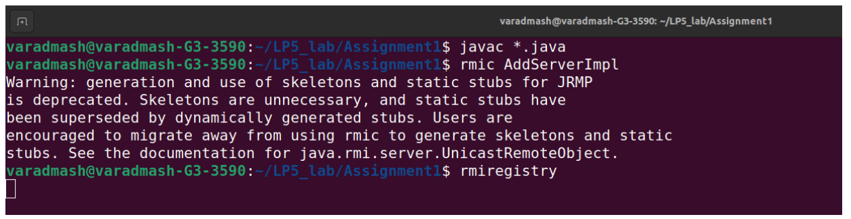

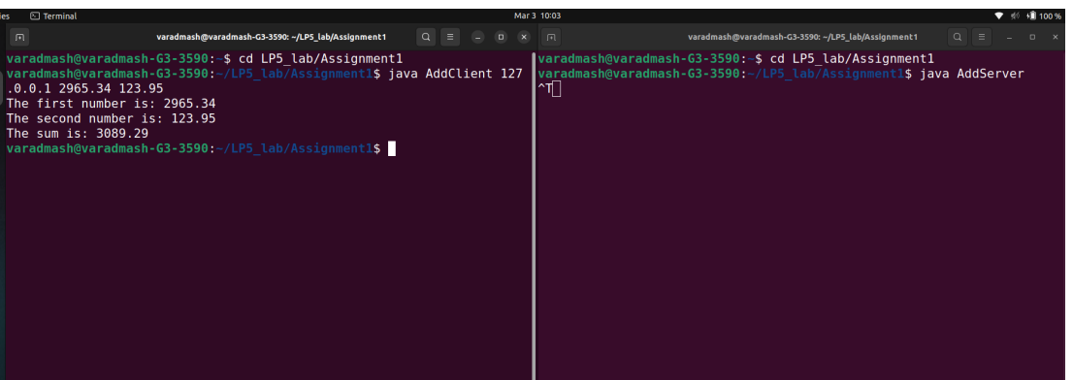

dynamight@dynamight-gemgd42:

dynamight@dynamight-gemgd42: ~/LP5_lab/Assignment1

dynamight@dynamight-gemgd42: ~/LP5_lab/Assignment1

dynamight@dynamight-gemgd42:

dynamight@dynamight-gemgd42:

dynamight@dynamight-gemgd42:

dynamight@dynamight-gemgd42: